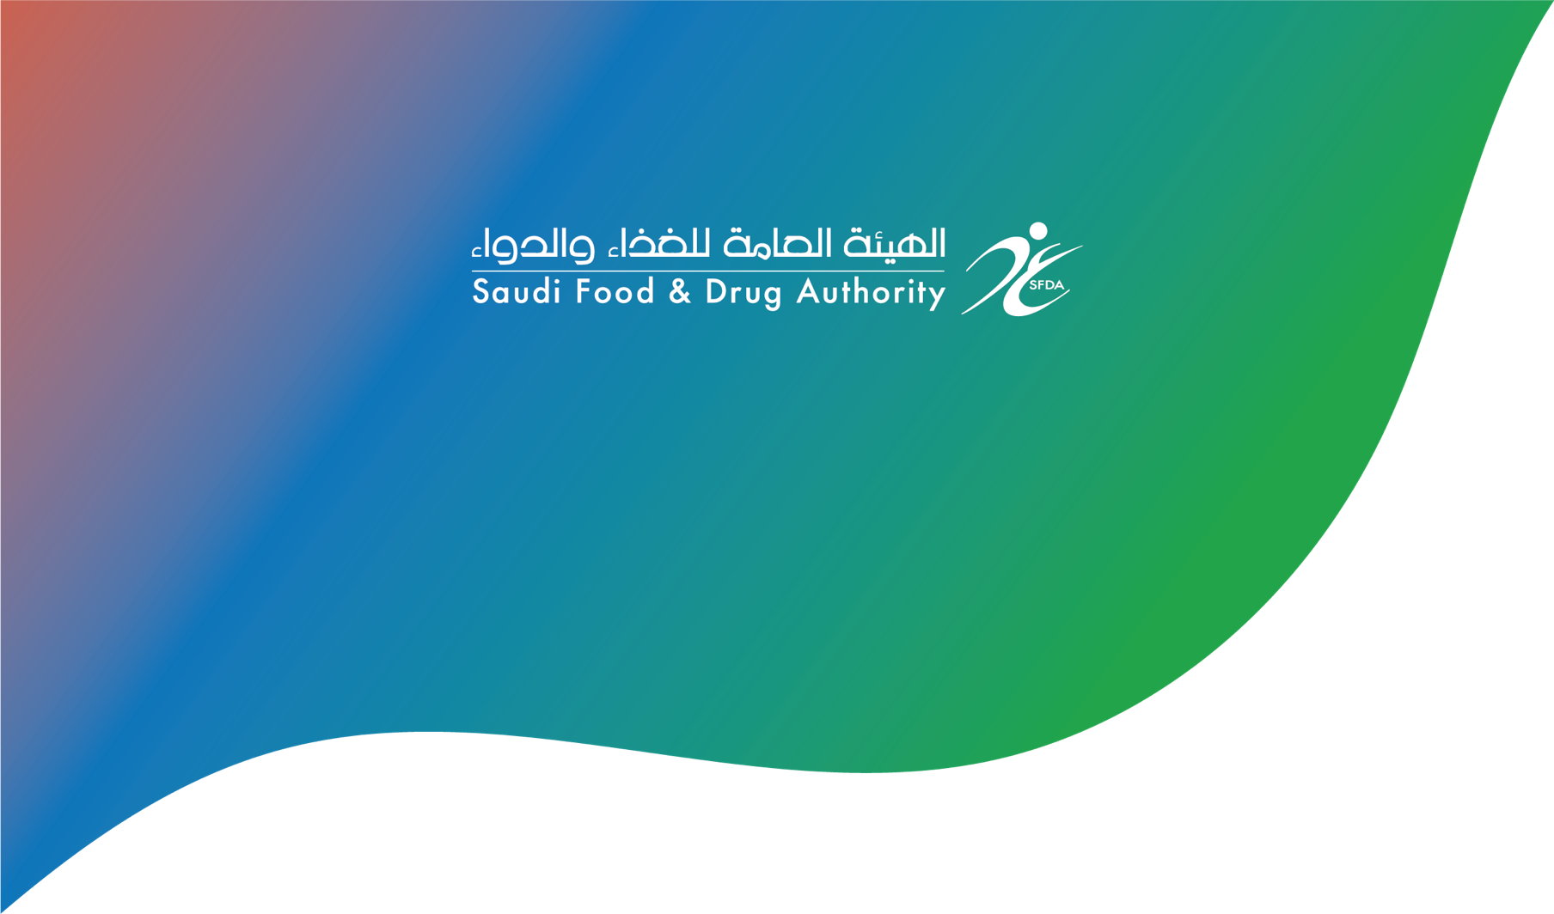

Application for Variation to a Marketing Authorization
طلب التغييرات على رخصة التسويق

Product type: | □ Human Medicinal Product  □ Health/Herbal Product  □ Veterinary Product
Sub-product No.
Request No.
Registration No.

1. Product information:
Trade Name:
Active Ingredient(s):
Dosage Form:
Strength/Unit:
Package Size(s):
Route of Administration:
Primary Packaging:
Secondary Packaging:
Approved Shelf Life:
Approved Storage Conditions:
Marketing Authorization Holder:
Agent:

2. Type of the variation:
- Type II
- Type IB
- Type IA
- Type IA_{IN}
- Annual Report

3. This application concerns:
- Administrative Changes
- Quality Changes
- Safety, Efficacy, or Pharmacovigilance Changes

4. Does this change affect the last updated drug application form?
- Yes
- No

5. Type(s) of Variation(s):
5.1 Variations included in this application:
Number and title of variation, as per the GCC guidelines for the variation requirements | Procedure Type | Date of Implementation

5.2 Precise scope and background for change (Include a description and background of all the proposed changes with its proposed Classification):
Current | Proposed

6. Declaration:
- I hereby certify that the submitted information is true and accurate.
- The submitted variations in this application is only variations that will be studied by SFDA

Title:
Name:
Signature:
Date:
Company stamp:

